** Archangel Michael Just a word**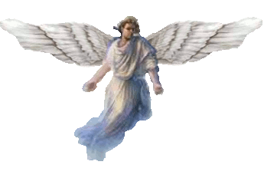

**There are many more Angels than people. We are Watchers, we don't interfere. There are a great many of us all over the Earth.**

**The wings of the small ones are much larger than depicted. We exist in many realms at the same time.** 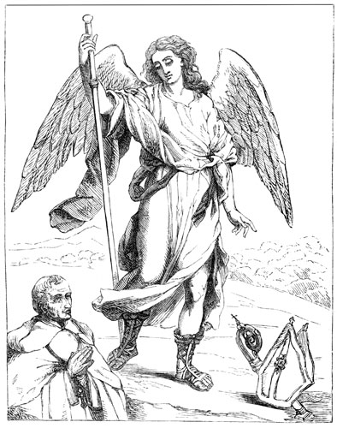

**The humans are only one of many species here on this planet. Many are bad and attack the people here.**

**This world is destine for death. It is the only way to destroy the evil here.**

**The Angels will just leave when this world ends. If the humans can't leave then 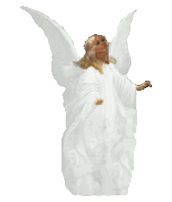they also will die.** 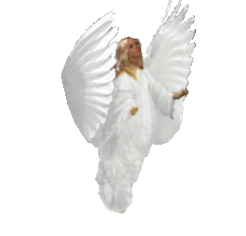

**We can't transport their bodies, there is simply no way. Star Gates or Time Travel can only transport spirits not the bodies of this dimension.**

**A short time before I heard this, I had an experience that literally shook me.**

**Saw Michael the Archangel before me, less than three feet. I could have reached out and grabbed his robe.**

**I was sitting in the bathroom in the middle of the night. The door was open to the hallway. Suddenly he appeared in the hallway forcing his way down it as he was quite large. The hallway was very tight around him, he could only go very slowly, a little at a time. I must have taken him more than five minutes to pass the opening to the restroom. During that time, he did not seem to know that I was even there.**

**The hallway is only seven feet high. His head was about six inches from the ceiling, his wings were crushed up against the ceiling and pushed down a great deal. They were feathers, very large ones and smaller ones as well. The bottom of them bent along the floor for about three or four feet, thinning to the end. They were very full and the tow of them also pushed along the sides of the hallway a great deal. As I say very large wings. All were a white-white. His robe was the same color, it went down to around his ankles. There the straps from his sandals wrapped up from his sandals. They were the old fashion type, just straps up from the souls of his feet, a medium brown. He was clean shaven although I could not tell if he had ever shaved.**

**He had nothing in his hands. His hair was a great surprise to me. Brown and long to his shoulders, not straight but hanging down then turning into curls of about five inches, then ending. Starting on one side of his face going around his head to the other side of his face. There were no bangs in front.**

**He was a large being, so striking. Bright and human-like. He never turned his head to look at me and I never said anything to him when he passed the doorway I could not see him anymore. I sat there stunned.**